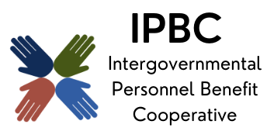
The premier health benefit option for Illinois local governments

Operations Committee Meeting Agenda
November 4, 2025, 9:30 am
Join the meeting now
Meeting ID: 274 466 092 010 8
Passcode: aC3bH9YZ

Dial in by phone
+1 323-792-6282,,706725712# United States, Los Angeles
Find a local number
Phone conference ID: 706 725 712#

- Call to Order Page

- Consent Agenda
  - Approval of Remote Participation
  - Minutes of September 9, 2025

- Officer Reports
  - Taskforce Recommendation on Benefit Consulting Options - Verbal

- Action Items
  - 2026 EHS Agreement (Attachment 2) 6
  - Cancer Advocacy Services Recommendation (Attachment 3) 14

- Discussion/Information Items
  - September Monthly Reports (Attachment 4) 41

- Old Business

- New Business

- Confirmation of Next Meeting – January 13, 2026, 9:30 am

- Adjournment

