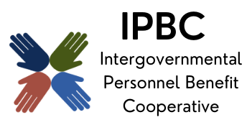

The premier health benefit option for Illinois local governments

Finance Committee Meeting Agenda
November 6, 2025, 9:30 am
Teams
Join the meeting now
Meeting ID: 279 490 605 839 9
Passcode: wv2jk2AM

Dial in by phone
+1 323-792-6282,,581930182# United States, Los Angeles
Find a local number
Phone conference ID: 581 930 182#

- Call to Order Page #
- Action Items
  - Consent Agenda
    - Approval of Remote Participation
    - Minutes of September 11, 2025
  - Award of ESI Audit for the 2024-25 Plan Year
  - Award of the ESI Marketing Check for the 2025-26 Plan Year

- Discussion/Information Items
  - Cash & Investment Portfolio as of September 30, 2025
  - June 30, 2025 Year-End Financial Reports
  - September 2025 Monthly Financial Reports

- Old Business
- New Business
- Confirmation of Next Meeting – January 15, 2026, 9:30 am
- Adjournment

